Synergies and Exploratory Procedures for Haptic Object Recognition

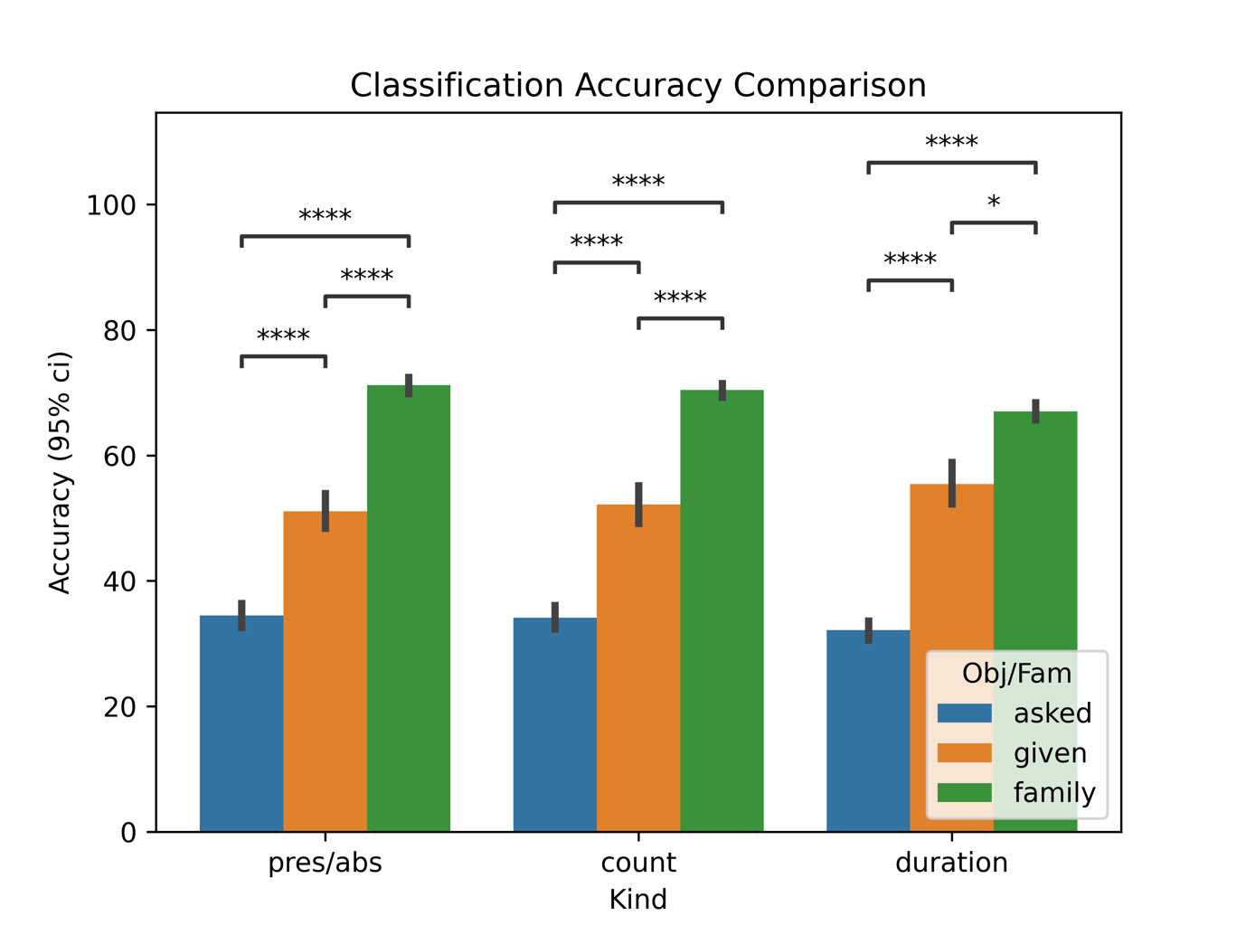
Figure 1. This figure depicts the classification accuracy for different classifiers. These classifiers are based on different inputs (the presence or absence of a particular Exploratory Procedure, the number of times each EP appears in a trial or the time spent on each EP) and target variables (the object we gave to the subject in that trial, the object we asked for and the family for that trial). We cannot appreciate any difference in the classification accuracy with respect to the input used. These results show significantly different accuracies for different target variables. We can see the EPs used are strongly related to the family (~70% accuracy with a chance level of 20%) as expected from previous work by Lederman & Klatzky [1]. We can also see a difference in accuracies between the asked object and the given object as target variables (with ~50% and ~33% accuracies respectively with a chance level of 33%). These results suggest that the selection of EPs is primarily guided by the perceived properties of the object being manipulated rather than the object they are asked about.

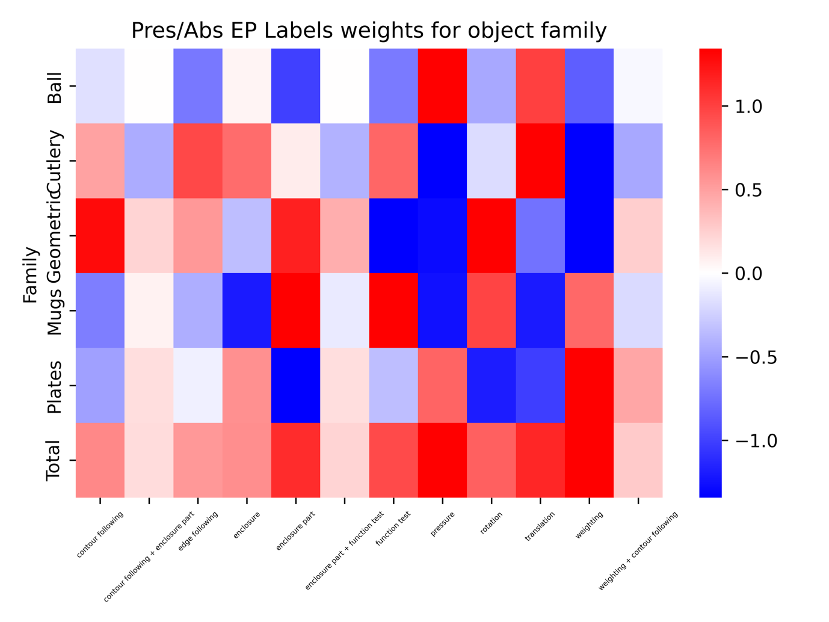
Figure 2. This figure shows the weights associated to each variable (EPs in our case) built to predict the object’s family based on the presence or absence of the EPs. The total row is computed as the mean of the absolute values for each family. Positive weights cause the model to categorize a trial as belonging to a specific family when the corresponding EP is present, whereas negative weights result in the model classifying the trial as not belonging to that family when the EP is present. The absolute value of the weight denotes the impact that the respective EP has on the final classification. E.g.: Those trials with the EP pressure won’t be classified as mugs, geometric or cutlery but as plates or more probably, as sports balls. This is a numerical approach to the results previously reported by Lederman & Klatzky [1].

Figure 3. This figure depicts the evolution in classification accuracy as we discard synergies compared to the accuracy for the classifier using the raw data. All results correspond to classifiers based on kinematic data for predicting the given object. X axis corresponds to the percentage of synergies used for that result. Y axis shows classification accuracy (95% c.i.) and variance explained. In the first row, the results obtained are shown after progressively discarding less relevant synergies (those accounting for less variance), while in the second line, the more relevant synergies are being discarded. First column shows results when synergies are extracted for all subjects together, second column when synergies are extracted for each subject and then paired using a clustering algorithm and third column when synergies are extracted from the Early Enclosure (data from first and second EP performed on each trial if that EP is enclosure or partial enclosure, extracted for each subject and then paired). In the first row, we can see how the accuracy is maintained even when retaining only the top 10% most relevant synergies. In the second row, we observe how the accuracy is maintained until we retain only the 40-50% of the less relevant synergies, even when the variance due to these synergies is very low. These results suggest that object-dependent information is available in high-order synergies (those accounting for less variance). This would align with previous hypothesis [2] suggesting that these synergies are not noise but rather correspond to fine movements, in contrast to lower-order synergies that would correspond to coarser movements.

[1] R. L. Klatzky and S. J. Lederman, “The intelligent hand,” Psychol. Learn. Motiv., vol. 21, pp. 121–151, 1987, doi: https://doi.org/10.1016/S0079-7421(08)60027-4.
[2] Y. Yan, J. M. Goodman, D. D. Moore, S. A. Solla, and S. J. Bensmaia, “Unexpected complexity of everyday manual behaviors,” Nat. Commun., vol. 11, no. 1, pp. 1–8, 2020, doi: 10.1038/s41467-020-17404-0.

